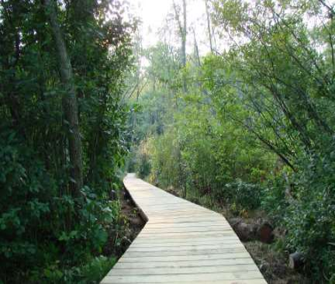

Boardwalk and Bridge Construction Guidelines

Acton Land Stewardship Committee
Acton, Massachusetts
February 12, 2026
Draft

NOTICE TO AGENCIES OUTSIDE THE ACTON LAND STEWARDSHIP COMMITTEE
THESE GUIDELINES DO NOT CONSTITUTE A SPECIFICATION AND ARE INTENDED SOLELY AS A GUIDELINES. THEY SHOULD NOT BE USED IN ANY MANNER WHICH REPRESENTS THEM AS BEING A STANDARD OR POLICY OF THE ACTON LAND STEWARDSHIP COMMITTEE.
Introduction ‒ The Land Stewardship Committee developed these guidelines for boardwalk construction after it was formed in 1996 to manage the conservation lands of the town of Acton, Massachusetts. Analysis of earlier constructed boardwalks led to corrective construction procedures that are presented here to assure the following qualities: level and stable deck surface, strength, ease of disassembly and/or repair, non-polluting, extended life, and less susceptibility to vandalism.
The original 2016 Guidelines by Bob Guba were revised and augmented in 2025-26 by the Land Stewardship Committee.
Boardwalk Sections
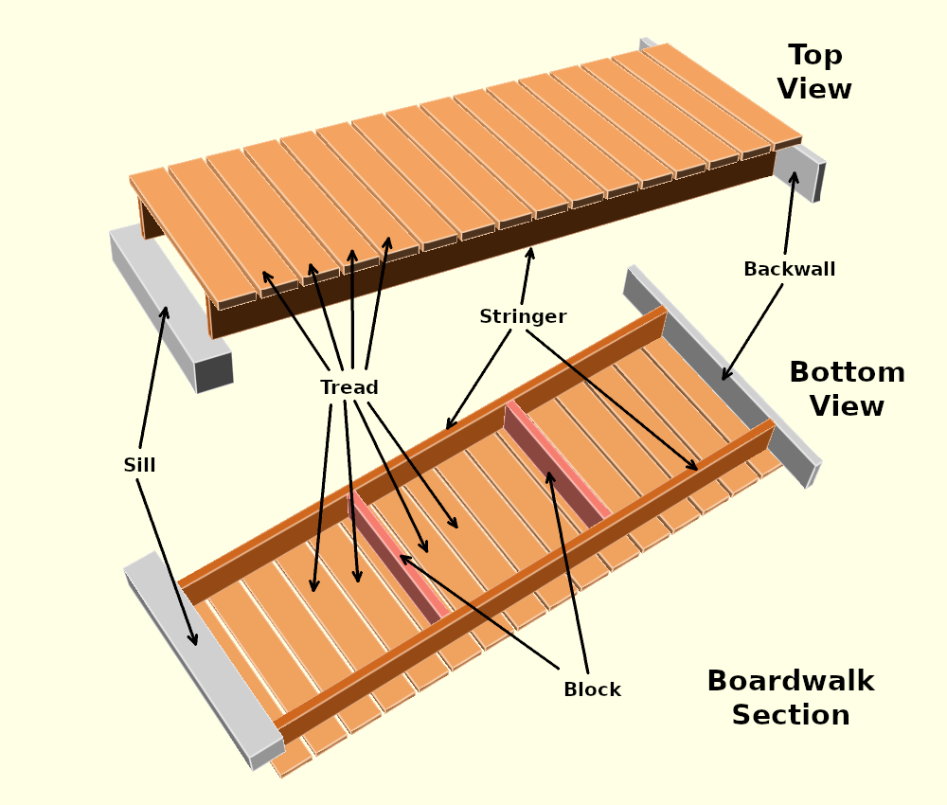
A boardwalk section consists of (2) stringers and (16) treads (for a typical 8-ft section). An end that connects to another section is mounted on a sill. An end that is buried in the ground has a backwall. Blocks may optionally be added to strengthen the section.
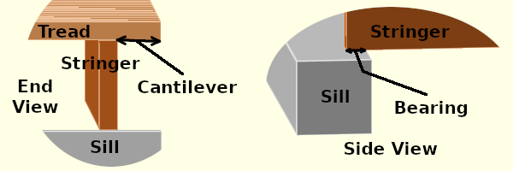

Standard Parameters

Stringer: 2x8, at most 8 feet long
Tread: 2x6 3 feet long
Sill: 6x6 3 feet long
Backwall: 2x8 4 feet long
Block: 2x8 26 inches long
Cantilever: 3.5 inches
Bearing: at least 1.5 inches

All wood is pressure-treated, ground-contact-rated Southern Yellow Pine.
Note: This guide uses nominal dimensions (e.g. 2x4, for which actual dimensions are 1.5”x 3.5”). Also, 8 foot stringers are usually 8’ 1” long as sold – we ignore the difference between 8’ and 8’ 1” except when spacing treads.
Stringer ‒ 2x8 at most 8 feet long, or 2x6 at most 6 feet long. Also see Bridge Sections.
Tread – 2x6 3 feet long. Should be mounted green-side-up: see Tread Mounting. Also see Tread Placement.
Sill – 6x6 3 feet long. There are several ways of making a sill: see Alternative Sills. What is under the sill, most often just the ground, is called the Sill Foundation.
Backwall – 2x8 4 feet long. This is fastened to the end of the stringers and is buried in dirt along with the stringer ends. It protects the stringer ends from decay caused by contact with dirt, and stabilizes the buried ends.
Block – 2x8 26 inches long. This stabilizes the section if it is moved as a unit, with or without treads attached. Otherwise it is optional.
Cantilever – 3.5 inches. This is the overhang of the tread beyond the stringer to which it is attached.
Bearing – at least 1.5 inches. This is the overlap of the bottom of a stringer with the top surface of a sill. It can be surprisingly short.
Fasteners and Connectors
Tread to Stringers – 3 inch deck screws with T25 Torx head (aka “Star” drive); either #9 ceramic coated steel or #10 stainless steel, rated for pressure-treated lumber. (2) deck screws from tread to each stringer (= 4 screws per tread)
Backwall to Stringers – ¼ inch hot dipped lag screws, 4 inches long, with hot dipped washers. (2) screws from backwall into the end of each stringer. See Lag Screws.
Block to Stringers – ¼ inch hot dipped lag screws, 4 inches long, with hot dipped washers. (2) screws from each stringer into an end of the block. See Lag Screws.
Stringers to Sill – If the sill has a wood surface, a T-Strap connector is used. See T-Straps. Sills that are aluminum pipes use a pipe side bracket: see Aluminum Pipe Sills.

Alternative Sills – Boardwalks should be fairly level, and this requires that sills be of varying heights. The ground under sills, called the sill foundation, also varies, and different sill foundations support different kinds of sills.
The sill foundation consists of soil on top of what the New England colonists called hardpan. The hardpan is something like concrete: it is impervious to water and digging, though you can chisel it easily. There may also be rocks and larger roots embedded in the soil or hardpan. In our area, hardpan typically consists of very highly compacted clay.
The soil gets its strength from innumerable small roots. Running water, even if it is only present on slopes during rains, causes erosion that can damage sill foundations over a longer period of time, such as a decade. Flooding can also cause erosion.
The soil depth can be determined by pushing a probe consisting of a 3/16 inch steel rod into the soil until it strikes hardpan (or a rock or large root). Soil depth where there is erosion is typically 4 to 12 inches. Soil depth where there is no erosion is often deeper.
There are three types of sills: wood, corrugated plastic pipe, and aluminum pipe.
Sill Types
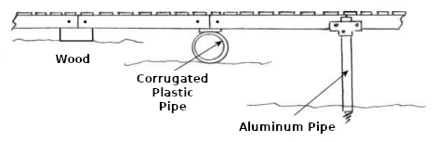
Wood Sills – Wood sills are made from ground contact Southern Yellow Pine. The top and bottom surfaces should be 6” wide (5 ½” actual). Sill length is at least tread width (e.g., 3 feet).
For a wood sill, the sill foundation may consist of soil only if it is not subject to erosion. If the probed soil depth is 12” or greater assume the soil is not subject to erosion. If the soil depth is 8” or less assume the soil is subject to erosion. Otherwise check whether the soil is sloped so water will run off it (erosion), or is subject to flooding involving running water (erosion), or is level and not involved with running water so water will puddle (no erosion).
In places that are subject to erosion, the soil under the wood sill must be removed and the ends of the sill must be supported by rocks or wood placed on top of the hardpan. Rocks can be replaced by concrete blocks. Rocks and concrete blocks can only be placed on hardpan or embedded rocks, and must never be placed on soil or roots. Also see Backwalls and Erosion.
There are many possible wood sill profiles:
Some Possible Wood Sill Profiles
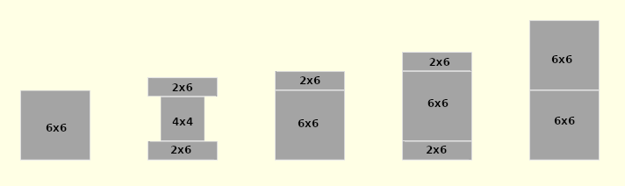
6x6s can be replaced by 4x6s

2x6s can be fastened to other sill wood by stainless steel tread screws. Two 6x6s can be fastened together by 10 inch long hot dipped lag screws (see Lag Screws). Fasteners should be more than 5” from sill ends to avoid interfering with stringers and T-straps.
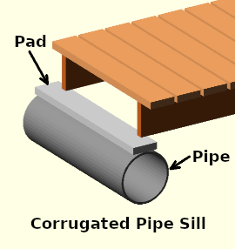
Corrugated Plastic Pipe Sills – A 3 foot long 2x6, called a pad, is attached to a 3 foot long corrugated plastic pipe using ⅜” hot-dipped carriage bolts (this is one of the few places that carriage bolts are allowed). The surface of the pad then plays the role of the surface of a wood sill. The carriage bolts should be more than 5” from the ends of the pads.
Corrugated plastic pipe can be used on soil subject to erosion. The main consideration is to keep erosion and gravity from rolling the pipe a bit over a very long period of time. If possible, dig a shallow trench for the bottom of the pipe. If the pipe is placed on a slope, wedge rocks or drive rebars into the ground on the down-slope side. If a pipe rolls due to erosion it will end up under only one of the two stringers it is supposed to support.
The corrugated plastic pipe must be dual wall, smooth interior, corrugated exterior, high density polyethylene (HDPE) pipe (e.g., ADS N-12). The following are the allowed sizes:

Inside  Diameter | Outside  Diameter | Height with Pad | Carriage Bolt  Minimum Length
8 in ** | 9.1 in | 10.6 in | 3 in
10 in | 11.4 in | 12.9 in | 3½ in
12 in | 14.5 in | 16 in | 4 in
15 in | 18 in | 19.5 in | 4 in
18 in | 22 in | 23.5 in | 4½ in

** Only use 8” in special circumstances (seek advice).

Aluminum Pipe Sills – Aluminum pipe is used to build docks, and may be used to support stringers in places where other sills will not work, such as muddy streams. The pipe is used with side brackets:
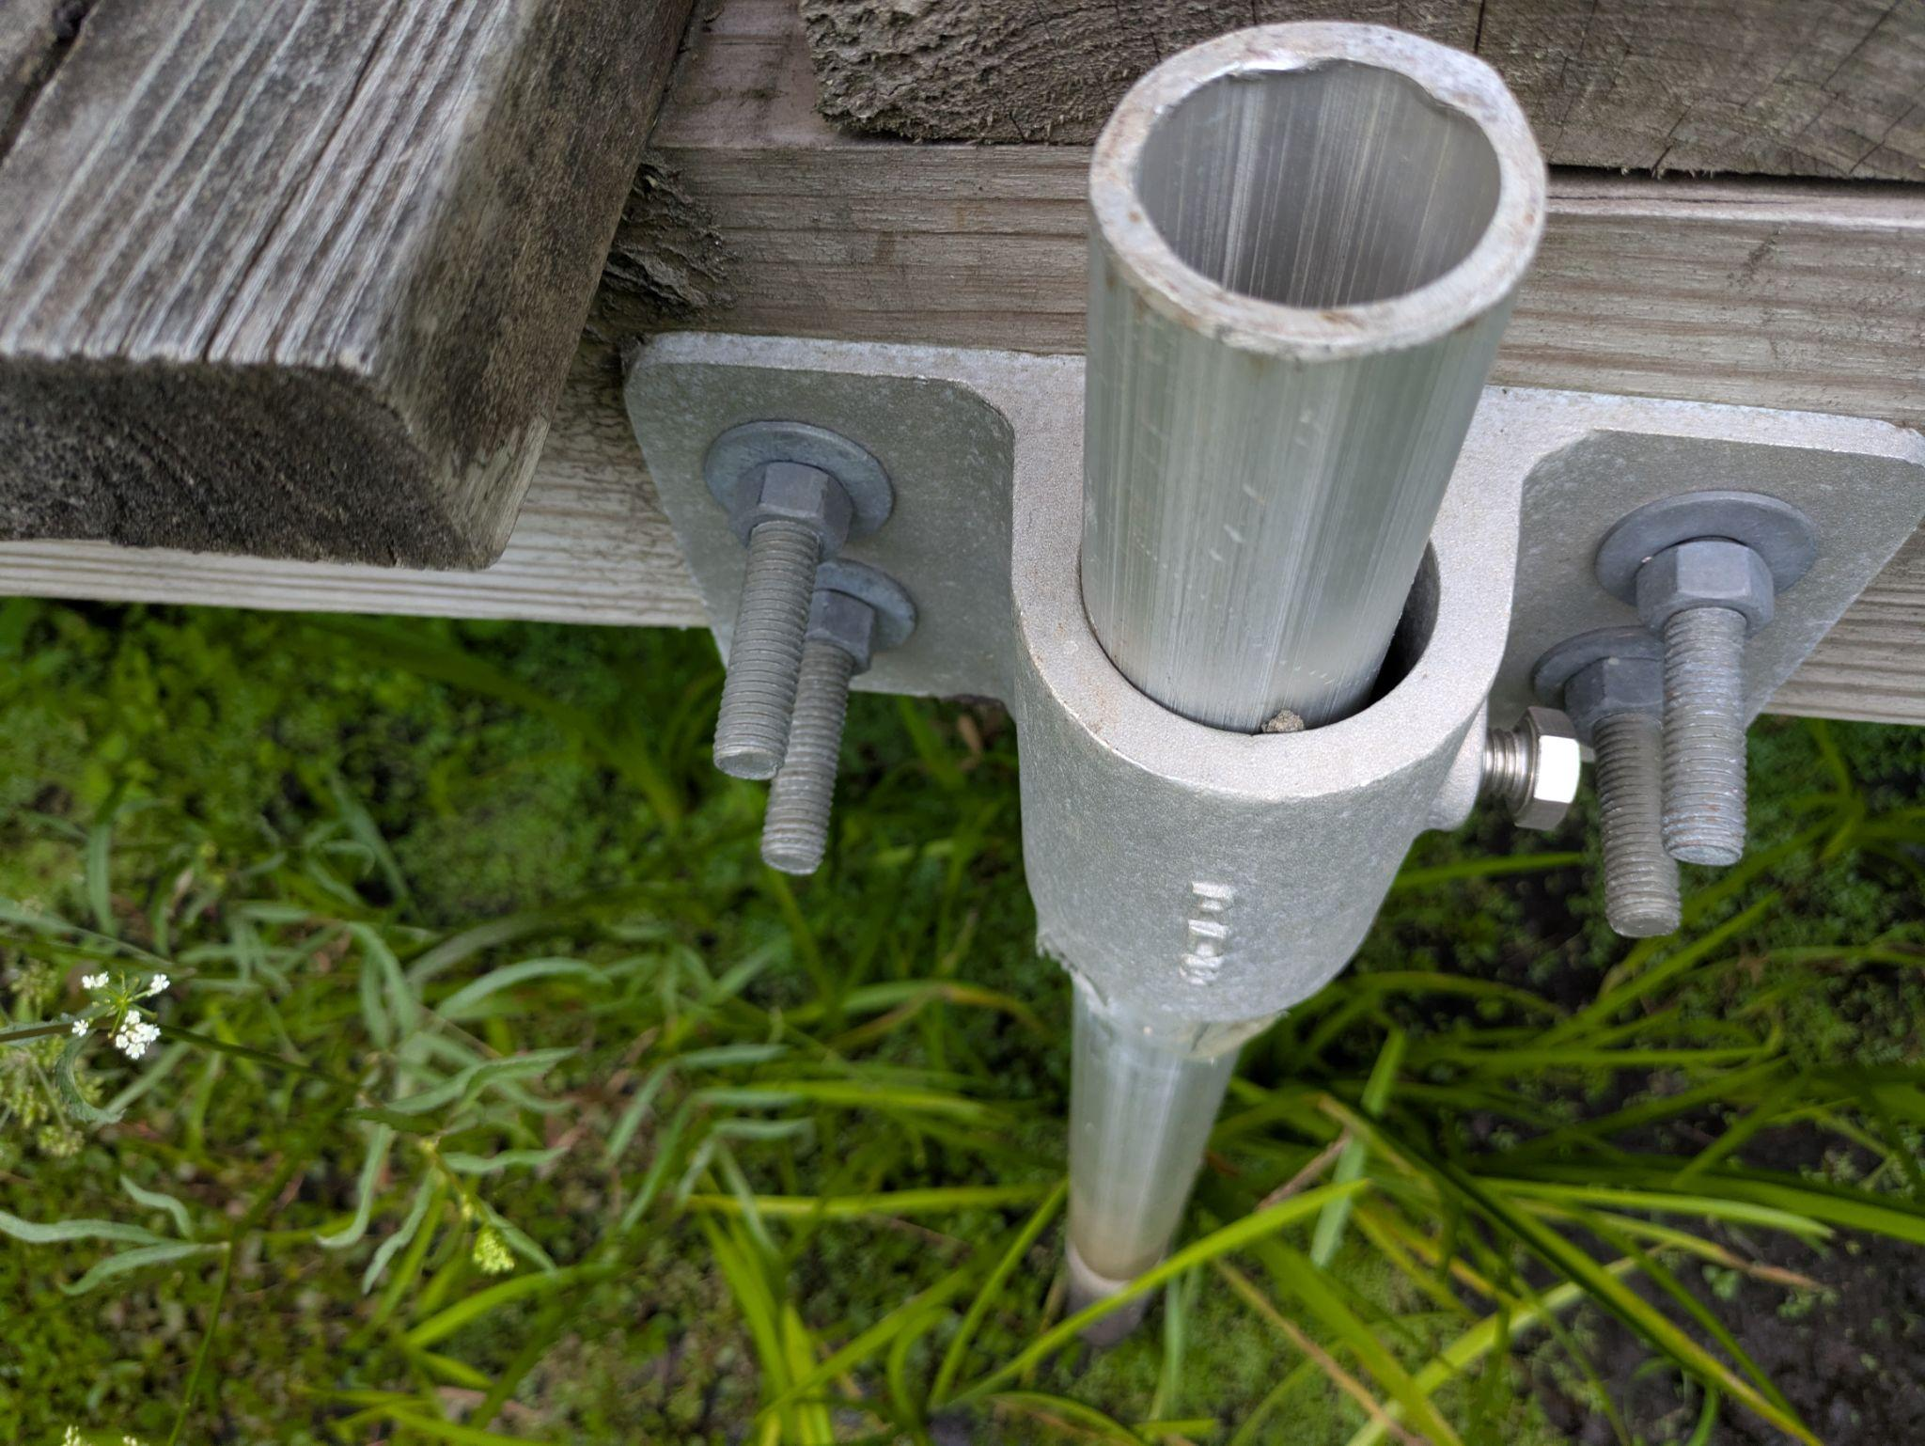
We use pipe with 1 ½ inch inside diameter (and almost 2 inches outside diameter).

To drive the pipe into the ground, we use heavy hammers. To protect the top of the pipe, a ductile iron drive cap may be used. If after installation the pipe sinks, a pipe chain jack can be used to reset the side bracket height. Be sure installed pipes have enough height to allow for sinking. We do not recommend using augers in the Acton area.

Backwalls and Erosion – Backwalls are longer than treads to promote extra stability of a boardwalk end.

If in addition, the ground beyond the backwall slopes upward, erosion may force dirt between the end tread of the boardwalk and the stringer on which it is mounted, pushing the tread up. To prevent this, the height of the backwall may be increased, so its top is flush with the top of the treads instead of with the bottom of the treads. For example, the backwall for 2x8 stringers may be a 2x10, with ½” extending below the bottom of the stringers and 1½” extending above the top of the stringers.
T-Straps – A sill supports and connects two boardwalk sections. If the sill has a 6 inch wide wood surface (5 ½” actual size), the sill and two stringers are connected by a bent T-Strap. Thus T-straps are used for both wood and corrugated pipe sills. The bent T-strap keeps the boardwalk sections together and attaches them securely to the sill.
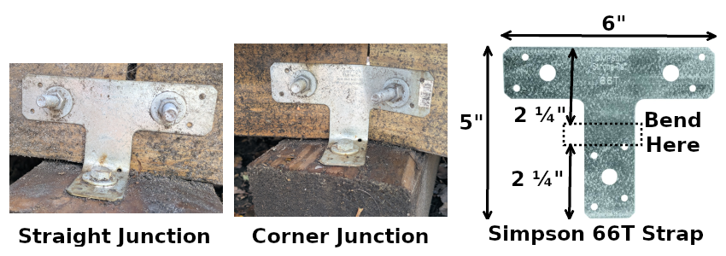
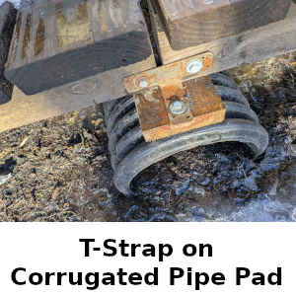
Bend the T-strap so that the top 2¼” and bottom 2¼” remain flat. The T-strap is connected to each stringer by a ⅜” hot dipped hex-head bolt 2½” long, with a nut and (2) washers. The T-strap is connected to the sill by a ⅜” hot dipped lag screw 3” long, with a washer. For corner junctions one of the `wings’ of the T-strap is bent.

Wood – Wood should be ground-contact Southern Yellow Pine. Treads and stringers should be #1, sills may be #2 or #1.
Sometimes #1 lumber pieces are delivered with defects and should not be used. Particular defects are knots that go all the way through the board and may pop out, and splits that go all the way through the board and may expand with time and separate the board into parts. Another defect is bow which develops over the first months after delivery: it appears that the heartwood side (of an occasional board) has moisture left over from kiln drying and contracts more than the green side.
Hex-Head Bolts – The length of a hex-head bolt must be exactly the thickness of the wood it goes through plus 1”. This is because only 1” of such a bolt is threaded (for bolts 8” and longer 1¼” is threaded). For example, the bolt attaching a 2x8 stringer to a T-strap goes through 1½” of wood, and therefore should be 2½” long.
A hex-head bolt should be attached with (2) washers, one under the head and one under the nut. Both bolt and washers should be hot-dipped.
To tighten or loosen a hex-head bolt you need (2) wrenches, one for the head and one for the nut.
Lag Screws – Lag screws (a.k.a., lag bolts) must be mounted with a pilot hole extending the entire length of the bolt, and a shank hole equal to the diameter of the bolt extending the length of the shank (the shank is the part of the bolt next to the head that has no threads — drill the shank hole first).

Lag Screw Size | Shank Hole Drill Size | Pilot Hole  Drill Size | Withdrawal Force per Engaged Inch
¼ in | ¼ in | 5/32 in | 260 lbf
⅜ in | ⅜ in | ¼ in | 350 lbf
½ in | ½ in | ⅜ in | 430 lbf

The ½” tapered tip of the lag screw does not count as engaged thread. For withdrawal from the end grain, withdrawal force must be multiplied by 75% (i.e., by 0.75). Withdrawal forces are applicable only to Southern Yellow Pine.

Non-lag screws must not be driven into end grain.

A lag screw must have a washer under its head. Both the lag screw and washer must be hot dipped.
Site Survey – The first step in building a boardwalk is a careful survey of the site where a boardwalk is to be built, as this will govern its design, materials, and cost. Place garden stakes along the centerline of the trail in the wetland where the boardwalk is to be located at stringer length intervals, at most 8 feet apart when stringers are 2x8s and at most 6 feet apart when stringers are 2x6s. If there are no natural barriers such as large trees and rocks to force the boardwalk to meander then slight turns every 30 to 40 feet should be incorporated into the design for an aesthetic experience.
The first and last stakes must be placed at points sufficiently elevated. The stringers at the ends of the boardwalk are buried at these points, and the tread bottoms are at ground level. The elevation must be such that all boardwalk stringer bottoms are above the water level almost all the time. This implies that all sill tops will be above the water level almost all the time.
A string is secured to the first stake two feet above ground level and continued to the following stakes using a string level. As a result each stake may be marked at a point 2 feet above the level of the ground at the starting point: we will call this the ground level mark. If the ground level mark on the last stake is not 2 feet above ground, the boardwalk will have to shift height. The rule is that boardwalk sections should not have more than a 3 degree slope, which is a 5” height shift in 8 feet or a 3¾” height shift in 6 feet. Using this guide, mark the stakes at a point 2 feet above where you want the tread bottom to be at the point of the stake. These marks will be called tread level marks. As we shall see, it is a good idea for the distance between a level mark and a tread level mark to be a multiple of 1½ inches (see Sill Placement).
If this procedure fails to shift enough height, build a short steeper ramp at one end of the boardwalk.
Now you can determine the height of the top of each sill, which is the height of the tread level mark above ground minus the height of the stringers (7¼“ for 2x8’s or 5½“ for 2x6’s) minus 2 feet.
Unless the sill is a wood sill on ground not subject to erosion you must determine the soil depth.
For a wood sill on soil subject to erosion, the soil at each sill end must be removed and replaced by rocks, concrete blocks, or wood, resting on the hardpan or embedded rocks below the soil. Rocks for this purpose should never be taken from stone walls. Gravel can be used in the bottom of a sill end support hole to make adjustments in the height of the sill. If the soil is too deep for this to be feasible, use corrugated pipe instead.
For a corrugated pipe a shallow trench should be dug to keep the pipe from rolling because of erosion. If the pipe sill would be too high, a deeper trench must be dug to get the sill height right. Gravel can be used in this trench to make adjustments in the height of the sill.
For aluminum pipe sills, the soil depth and sill height above ground determine the length of the pipe.
Sill support holes or corrugated pipe trenches should not be dug until the final position of the sill is determined. Typically this happens when a neighboring sill has been installed and a stringer can be run between it and the sill that is to be installed.
When a hole or trench is dug, after it has been filled with sill supports or a pipe, any remaining depression, including any inside the pipe, should be filled with dirt to avoid making puddles in which mosquitos can breed.

Sill Placement – Generally you build the boardwalk from one end, though if there is a critical middle section you might build that first and then treat the boardwalk as two separate boardwalks for construction purposes. If the boardwalk must shift height, start at the higher end.

When placing a sill, the far ends of stringers on one side of the sill already have a determined height. One of these stringers can be used as an 8 foot (or 6 foot) long `level’ to propagate this height to the position of the new sill. The new sill can then be installed at the right height. If the stringer is to shift height downward, put one or more treads on top of the new sill temporarly during placement, so that the top of the topmost of these treads is the same height as the other end of the stringer, and the stringer is level.

Maintain a ½” gap between stringers joined at a sill to allow vertical flexing of the boardwalk (e.g., during freeze-thaw cycles). Additionally, end treads should be mounted flush with stringer ends, and the ½” gap between stringers is also the normal tread gap between stringer end treads.

If the area experiences high flooding, anchor the sills by driving rebars through the sills and into the ground at an angle. A flood that covers the treads will float the boardwalk and move it to a place you do not want it to be, unless the sills are firmly anchored to the ground.
Plastic Pipe Sills – (Section To Be Deleted?) Figure 6 is an assembly drawing showing plastic pipe with an end view of stringer pads, brackets/hardware, stringer options and decking.
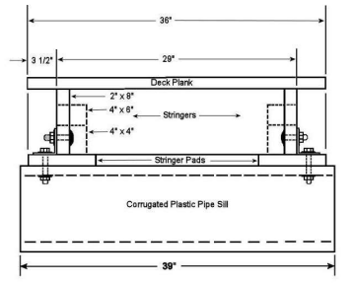Figure 6 – Corrugated Plastic Pipe Sill Assembly Detail
Decking – Decking treads are 2”x6”x3’ ground contact boards of #1 quality. Treads are attached with T25 torq head 3” deck screws, see section X either #9 ceramic coated steel or #10 stainless steel. Nominal spacing between treads is ½”, but spacing between ¼” and ¾” is acceptable.

To place treads on each stringer, make a mark ¼” from the stringer end, and then every 6” until the other end. Align one side of the treads with these marks. To get the 3 ½” tread cantilever correct, make a 3 ½” gauge from a combination square or a piece of wood.
Frame Stringers – (Section To Be Deleted?) Frame stringers are used to obtain more deck height where considerable water depth can be expected. Another reason is to minimize the number of costly pipe and dock fittings by increasing the stringer span length. Figure 8 depicts the construction of a frame stringer using 2” lumber. This design can be assembled off site with three deck planks attached for strength in transport.
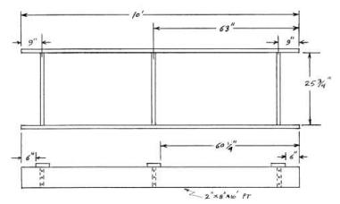Figure 8 - Stringer Frame
6 Rev. 9/1/2016

Tread Mounting – Treads are 2x6 3 foot ground contact boards of #1 quality, attached with deck screws, see Fasteners and Connectors: Tread to Stringers. Nominal spacing between treads is ½”, but spacing from ¼” to ¾” is acceptable.
To place treads on each stringer, make marks on the stringers at regular intervals from one end of the boardwalk section. See Tread Placement for details. Align one side of the treads with these marks. To get the 3 ½” tread cantilever correct, make a 3 ½” gauge from a combination square or a piece of wood.
A 2x6 plank typically has a bark/green side and a pith/heartwood side. This occurs when the plank is cut from near the surface of the log in the sawmill. The green side may be cut so close to the surface that some bark is included in the plank, and then this is peeled off leaving a shaved edge called wane.
For treads the green side should be the top side, even if it has wane. The heartwood side should be the top side only if the green side has serious defects other than wane. The main reason for this is that the wood preservative penetrates the green side better than it penetrates the heartwood side, and the top side is more subject to decay.
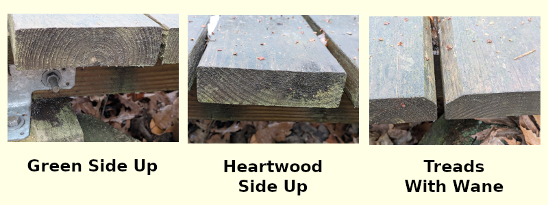
Tread Placement – The standard gap between treads is ½”, though gaps from ¼” to ¾” are acceptable. A 5½” tread plus adjacent gap is nominally 6”.
Treads at the ends of a boardwalk section should be flush with the stringer ends. Then if stringers from joining sections are separated by ½”, the treads at the ends of these sections will be separated by a standard ½” gap.
If you start at one end of a boardwalk section and make a mark every 6” and place a tread at the mark, the last tread will not be flush with the stringer ends. If the stringer is 8 feet exactly, there will be a ½” gap at the stringer ends, and if the stringer is 8’ 1” (more likely), there will be a 1½” gap. Suppose the latter. There are 15 gaps and what we do is expand 12 of them to ½”+⅛” to cover the extra 1½”. So we make the first 3 marks at 6” intervals, and the remaining 12 marks at 6⅛” intervals.
If instead one end of the boardwalk has a backwall, we want to place the tread at that end flush with the outside of the backwall, so if we placed treads every 6”, we would have a 1½” + 1½” = 3” end gap. In this case make marks every 6” from all the stringer ends and mount treads on the marks, leaving a 3½” gap between treads in the middle of the boardwalk section. Then cut a tread to have only a 2½” width and mount it in the middle of the gap.
Boardwalk Corners
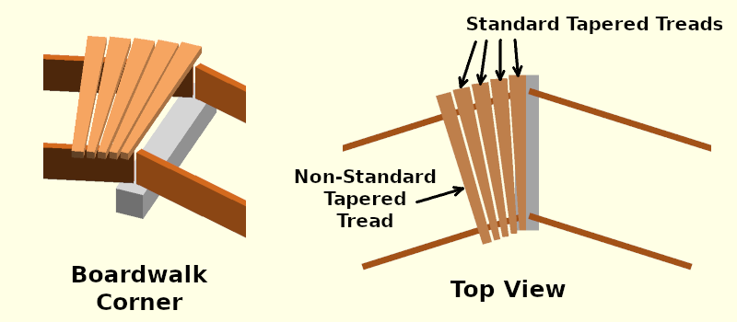
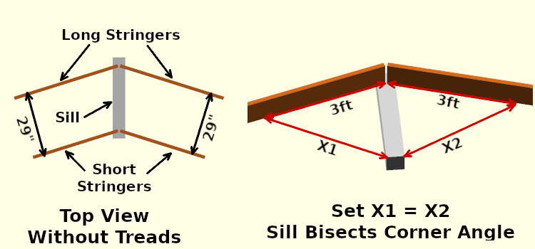
A boardwalk corner is where the boardwalk changes direction. The stringer pair on either side of the corner should be separated by the standard distances, which are 29” for the stringer outsides and 26” for the stringer insides. This means that the sill must bisect the corner angle.
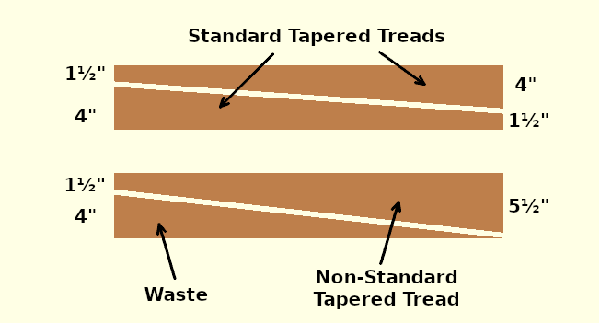
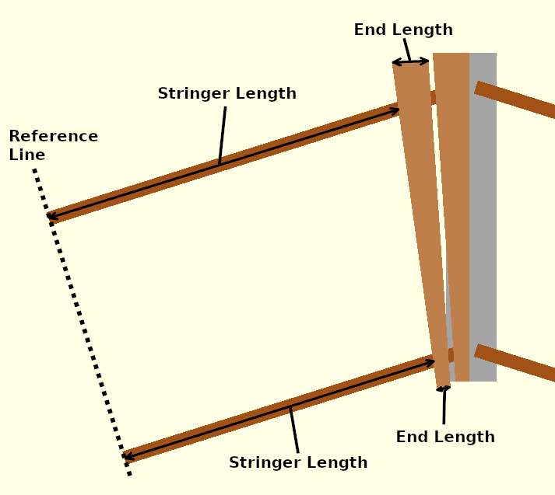
A diagonal cut in a normal 2x6 3 foot tread makes two tapered treads (or one tapered tread and a waste piece). If the lengths of the two ends of one of the tapered treads sum to 5½”, two geometrically identical tapered treads will be made. If the end lengths are 1½” and 4”, these will be standard tapered treads. No tapered tread end length should be less than 1½”.
Tapered treads can be viewed as mechanisms that reduce stringer length difference. Here we define stringer length as follows. Draw a reference line that is perpendicular to the stringers. If the boardwalk section has a corner at only one end, the non-corner end of the section can be used as the reference line. Then for each stringer measure the distance from the reference line to the nearest edge of the last tread installed, or to the corner end of the stringer if no treads have been installed on the stringer. The stringer length difference is the difference between the long stringer length and the short stringer length. If this is zero, no more tapered treads are needed for the section corner.
A tapered tread reduces the stringer difference. A tapered tread has a long end length and a short end length, and the difference is called the end difference. A tapered tread reduces the stringer difference by approximately 76% of the end difference, where 76% = 27½/36 is the portion of the end difference that is between the stringer centers. Thus a standard tread, which has an end difference of 4”-1½” = 2½” reduces the stringer difference by about 1.9”.
You can also reduce stringer difference by adjusting the gap between treads. A standard gap is ½”. A tapered gap can be ¾” on the longer stringer and ¼” on the shorter stringer, and reduce stringer difference by ½”.
The maximum edge difference for a non-standard tapered tread is 5½”-1½” = 4” which can reduce stringer difference by 3”.

Bridge Sections – A bridge section is just a longer than standard boardwalk section, possibly with 4 foot wide treads instead of the standard 3 foot wide treads. Bridge sections are used as bridges over gullies and small streams provided the height of the tread tops above solid ground is at most 3 feet and water in the gully or stream is not deep.

Bridge sections either have larger stringers or more stringers than standard boardwalk sections.

Maximum Spans

Number of Stringers
Size | MinimumBearing | 2 | 3 | 4 | 5 | 6 | 8 | 10
2x6 | 1.5 in | 6 ft | 7 ft | 8 ft | 8 ft | 9 ft | 10 ft | 10 ft
2x8 | 1.5 in | 8 ft | 9 ft | 10 ft | 11 ft | 12 ft | 13 ft | 14 ft
2x10 | 2.0 in | 10 ft | 12 ft | 13 ft | 14 ft | 15 ft | 16 ft | 17 ft
2x12 | 2.5 in | 12 ft | 14 ft | 16 ft | 17 ft | 18 ft | 20 ft | 22 ft

The bearing of a stringer is the portion resting on the sill and the span is the portion between the sills, not including the bearing.
Bridge sections should have wood sills at both ends. For bridge sections these sills should be supported by rocks or concrete blocks. If an end is dirt without supporting rocks, place the sill at least a foot from the side of the gully and and dig holes down to hardpan at each end of the sill. Then build up from hardpan with concrete blocks or rocks to support the sill. It's good to use wood with extra preservative (e.g., UC-4B) for sills that will be underground at the ends of bridge sections.
If a bridge section has 4 foot wide treads, it should have a middle stringer to support the middle of the treads.
If a bridge section has more than 3 stringers, stringers should be paired as follows. Two stringers are placed side-by-side and connected with flat head timber screws. Before connecting, spread polyurethane construction adhesive in a serpentine (repeated S’s) pattern on one of the boards. After drying, put a bead of adhesive on the top joint to prevent water from getting between the wood pieces. Use a type of polyurethane adhesive that has a wide operating temperature range (e.g., -40 to 160 degrees Fahrenheit).
Treads should have at least one tread screw into each stringer. For a stringer pair, there should be one tread screw into each stringer of the pair.
Non-Standard Stringer WIdths – Stringers other than 2x should not generally be used, but in case these are being considered, the following rules can be used to calculate the span:
- Spans are proportional to stringer height.
- Spans are proportional to the cube root of the sum of the widths of all the stringers, if this is at least 1.
For example, suppose we want to use (2) rough cut 10x10 stringers instead of (10) 2x12 stringers. For the (10) 2x12 stringers we have stringer height 11¼”, sum of widths 10x1½” = 15”, span 22 feet. For the (2) rough cut 10x10 stringers we have height 10”, sum of widths 2x10” = 20”, span 22 feet times (10”/11¼”) times cube root of (20”/15”) equals 21.5 feet. But the weight of a 24 foot rough cut 10x10 is (10/12)’ x (10/12)’ x 24’ x 34 lbf/cuft = 567 lb, while the weight of a 24 foot 2x12 is (11¼/12)’ x (1½/12)’ x 24’ x 34 lb/cuft = 96 lb, which is why we prefer 2x stringers.
Bridges - If a bridge section would have tread tops more than 3 feet above ground, or the stream or gully over which the bridge section passes has deep water during much of the year, then rails must be added to the bridge section to make it a bridge. The rails are added to posts, and the posts are supported by post sills and post braces.
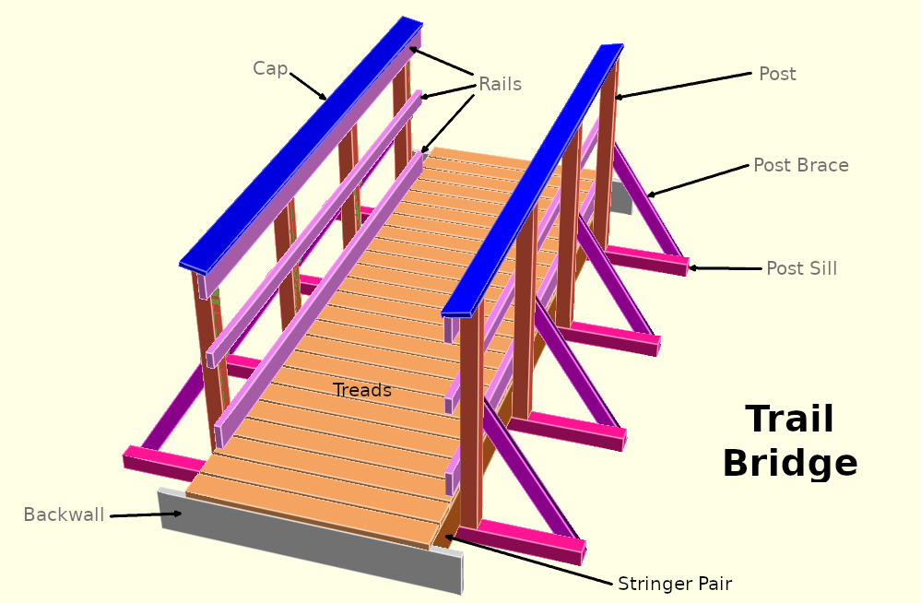
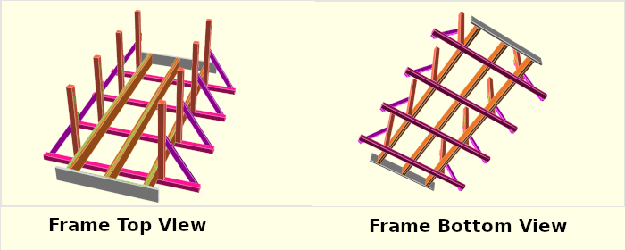
The stringers, backwalls, and treads form a bridge section, with the following differences. The treads are 4 feet wide, and their ends are flush with the outsides of the outside stringers (there is no cantilever). There is no blocking – the treads and post sills together are sufficient to keep the stringers in position.
Bridge Parameters
Treads – 4 foot long 2x6s. Tread ends are flush with the outsides of the outside stringers.
Post Sills – 8 foot long 4x4s. 2 foot overhang on each side.
Posts – 4x4s. Height of post outside above top of tread: 40½”. Total height of post outside: 40½” + 1½” (tread height) + stringer height (e.g.,9¼” for 2x10 stringers). Top of post is cut slanted toward the inside so cap will be slanted and drain water. Height of slant: ¾”.
Distance between posts: 3 to 4 feet.
Distance from end of span to nearest post center: at most 12”.
Post Braces – 2x4s. End connected to post is cut flush with the post (at a slant so it is flush with the outside of the middle rail). Topmost part of post brace is 24” above stringer top (24”-1½” above tread tops), which is also the height of the top of the middle rail.
Middle Rails – 2x4s. Top is 24” above top of stringers (24”-1½” above top of treads). See Post Braces. Length of rail equals span.
Bottom Rails – 2x6s. Bottom of rail is 3½” above tread tops (5” above stringer tops). Length of rail equals span.
Top Rails – 2x6s. Top of rail is such that when cap is mounted, the underside of the cap will just graze the top of the rail. Length of rail equals span.
Caps – 5/4”x6”. Mahogany or plastic wood. Should slightly overlap slanted post tops and top rail tops. Length of cap equals span.

Bridge Fasteners and Connectors
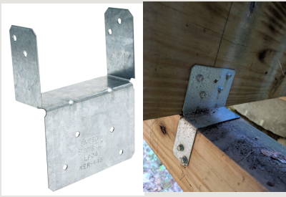
Post Sills to Stringers - Each post sill is connected to each non-outside stringer by a Simpson Strong-Tie LPC4Z Light Post Cap.

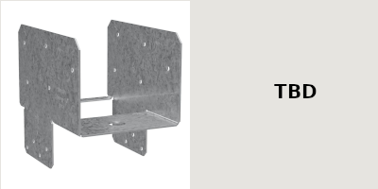
Posts to Post Sills – Each post is connected to a post sill by a Simpson String-Tie EPC4Z End Post Cap.

Post to Outside Stringers – A post is attached to its adjacent stringers by (2) Hex-Head Bolts. For each bolt use (2) flat washers and (1) lock washer (next to the nut). For a stringer pair these are 8” long (the 7½” length may be unavailable), and for a single stringer they are 6” long.
Brace to Post Sill and Post – A brace is attached to either a post or a post sill by a single 6” long Hex-Head Bolt.
Rail to Post – A rail is attached to a post by one or two 6” carriage bolts or 4” flat headed timber screws. These do not have sharp edges which can catch on people’s clothes.
Cap to Posts – A cap may be attached to the posts it sits on with tread screws. This violates the rule that non-lag-screws must not be driven into end-grain, but is acceptable as the screws are not subject to withdrawal force.

Materials List
Sills – 2x6, 4x6, 6x6 #2 or #1 ground contact pressure treated southern pine.
Dual wall, smooth interior, corrugated exterior, high density polyethylene (HDPE) pipe (e.g., Advanced Drainage Systems N-12).
Stringers – 2x6, 2x8. 2x10. 2x12 #1 ground contact pressure treated southern pine.
Treads – 2x6 #1 Ground contact pressure treated southern pine.
Connectors – Simpson Strong-Tie: T-Strap 66T, Light Post Cap LPC4Z, End Post Cap EPC4Z.
Fasteners – Hot Dipped ⅜” Lag Screws, Hex Bolts, Carriage Bolts, Flat Washers, Lock Washers, Nuts.
Simpson Strong-Tie: SDWS Timber Screw (with flat washer head and star drive), #10 x 3” 18-8 Stainless Star-Drive Bugle-Head Deck Screws.
#9 x 3” Star-Drive Ceramic-Coated Deck Screws.
Dock Hardware and Tools – RDS Dock Hardware: 1½” Schedule 80 Aluminum Pipe, 1½” Pipe Trim Cap, 1½” Pipe Side Bracket, 1½” Brace Bracket, 4’ x 10’ Dock Frames, SureStep™ Decking, 1½” and 2” Drive Cap, Pipe Chain Jack.
Some Useful Vendors – Bolt Depot, RDS Dock Hardware, BB&S UC-4B Marine Lumber (S4S or RGH).

The Bark-Side/Pith-Side Debate
This section is based on 2024 National Design Specification for Wood Construction (NDS), 12.1.4, 12.2.2.3, and Table 12.2A..

